Demo Link:<https://54.254.156.78:8443/websocketsdemo/customsipml5.html>

**1. Connect**

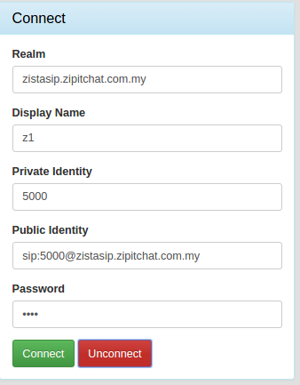

Realm: SIP server (zistasip.zipitchat.com.my)

Public Identity: SIP account ([sip:5000@zistasip.zipitchat.com.my](mailto:sip:5000@zistasip.zipitchat.com.my))

Password: SIP account password

Private Identity: 5000

Hit Connect Button to login. If connected successfully it's will show: "Connected" and the Call Box will be enable.

Hit Unconnect Button to logout. If logout successfully it's will show: "Disconnected"

**Test accounts:**

[sip:5000@zistasip.zipitchat.com.my](mailto:sip:5000@zistasip.zipitchat.com.my) , pass: 0000 , Private Identity: 5000

[sip:6000@zistasip.zipitchat.com.my](mailto:sip:5000@zistasip.zipitchat.com.my) , pass: 0000 , Private Identity: 6000

**2. Make a Call.**

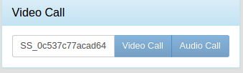

In the call box, we will fill the callee's Private Identity.

**Caller and callee must be connected to make a call.**

**If there's an incoming call during a call, the incoming call will be declined.**

**3.. Incoming call**

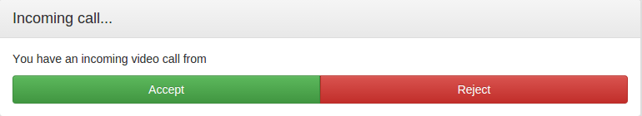

Accept Button: accept a call.

Reject utton: reject a call.

**4. During a call**

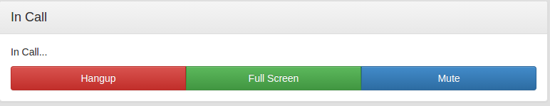

Hangup Button: Terminate the call.

Mute Button: Turn off the remote video/audio call sound.

Fullscreen Button: Remote Video call will be full screen.

**5. Send Message:**

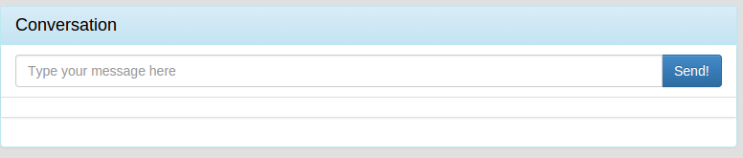

Send message to the Private Identity in call box